TABLE OF CONTENT

Sr. No. | Contents | Page No.
 | Abstract
1 | Introduction | 1
2 | Literature Survey | 2
3 | Problem Statement | 4
4 | System Architecture | 5
5 | Results | 7
6 | Outcomes and Applications | 8
7 | Conclusion | 9
 | References | 10

ABSTRACT
In today’s fast-paced digital world, people expect services to be delivered instantly with just a few clicks. From food delivery to transportation, technology has transformed the way services are accessed. However, when it comes to household maintenance such as plumbing, electrical repairs, cleaning, or appliance servicing, many people still rely on traditional methods of finding workers, which can be slow, inconvenient, and unreliable. This creates a gap between the growing demand for instant solutions and the availability of organized home service system.
The Instant Home Service System is an innovative digital platform designed to bridge this gap by providing quick, reliable, and on-demand home services. The system connects users with nearby verified service providers through an intelligent online platform. With a simple interface, users can request services instantly, and the system automatically identifies and assigns the nearest available professional to handle the request. This ensures faster response times and improves the overall service experience.
Unlike conventional service booking systems, the Instant Home Service System focuses on speed, accessibility, and efficiency. By integrating features such as real-time service requests, provider availability tracking, and automated service allocation, the platform ensures that household problems are addressed quickly and effectively. This approach not only enhances convenience for users but also creates better opportunities for service providers by increasing their visibility and job accessibility.
Overall, the Instant Home Service System represents a modern and innovative approach to managing household services. It leverages digital technology to simplify service booking, reduce waiting time, and provide reliable solutions for everyday home maintenance needs.

1.INTRODUCTION
The Instant Home Service System is a digital platform will be developed in future to provide fast and convenient household services to users within a very short time, typically around 10 minutes after placing a request. In modern urban life, people often face sudden problems at home such as electrical faults, plumbing leaks, appliance breakdowns, or the need for quick cleaning services. Finding a reliable service provider quickly can be difficult and time-consuming. The 10-Minute Home Service System addresses this issue by connecting customers with nearby service professionals through an online platform.
The system allows users to register and log in through a website or mobile application. After logging in, users can browse different categories of services such as plumbing, electrical repair, home cleaning, appliance servicing, carpentry, and maid services. Once a service is selected, the user can place a request, and the system automatically identifies the nearest available service provider based on location and availability. The service provider then receives the request and reaches the customer’s location as quickly as possible, aiming to deliver assistance within 10 minutes.
This system also includes several important modules such as user management, service provider management, service booking, and administration control. Users can view service details, track their service requests, and maintain a history of previous bookings. Service providers can manage incoming requests, update their availability, and provide timely services. The administrator is responsible for managing users, verifying service providers, updating service categories, and monitoring the overall functioning of the system.
The main goal of the 10-Minute Home Service System is to make household service booking faster, easier, and more reliable. By using digital technology and automated service allocation, the system reduces the waiting time for customers and improves the efficiency of service providers. Overall, the platform enhances convenience, saves time, and ensures that customers receive quick and trustworthy assistance for their household needs

2.LITERATURE REVIEW
The " Instant Home Service System " project builds upon existing research and technological advancements in home service management. Various studies have explored different approaches to improving service booking, reliability, and user satisfaction. This literature review synthesizes previous research and integrates key insights relevant to the development of this platform
In [1] Anusha M. G. and Kiran Kumar M. N. (2022) proposed a home service management system to address inefficiencies in traditional service booking processes. Their study highlighted challenges such as mismatched schedules, trust deficits, and lack of quality assurance. The proposed system incorporated real-time slot management and JWT-based authentication for secure user access. These findings are instrumental in shaping the "Instant Home Service Hub," particularly in implementing authentication mechanisms and dynamic scheduling features
In [2] Aravindhan et al. (2020) analysed web-based on-demand home service platforms designed to support real-time communication between customers and service providers. Their study pointed out several problems in existing systems, such as the lack of a centralized platform, poor coordination, and inefficient booking procedures.
The researchers proposed that integrating real-time updates, secure authentication methods, and smooth communication features could significantly improve the efficiency of home service applications. The study also emphasized the role of modern web technologies in enhancing user experience and service management.
In [3], Sheetal Bandekar and Avril D’Silva (2016) designed an Android-based home service application to provide easy mobile access for users seeking household services. Their research highlighted the importance of developing user-friendly interfaces and ensuring compatibility across mobile devices to improve user experience and accessibility.
The study emphasized that mobile-based platforms make service booking more convenient and accessible for users. It also demonstrated how simple navigation and responsive design can increase user satisfaction and system usability.
In this project, we attempt to implement Instant Home Service System, which helps users to avail different services like carpentry, electrical works etc., with following features:
- Quick and Easy Service Access:
To provide users with instant access to various home services such as plumbing, cleaning, electrical repair, carpentry, and appliance servicing through a digital platform.
- Real-Time and Convenient Service Management:
To reduce service waiting time by connecting users with nearby available service providers and allowing users to schedule, track, and manage services easily through mobile or web applications.
- Transparent and Secure Service Platform:
To improve service transparency by displaying pricing, service details, ratings, and reviews, while also enabling secure online payments through multiple digital payment methods.
- Better Opportunities for Service Providers:
To create a reliable platform for skilled workers and technicians to register, receive more job opportunities, and increase their visibility and income.
- High-Quality and Reliable Service Delivery:
To maintain service quality through feedback and rating systems, along with real-time tracking features that help users monitor service status and provider location.

3. PROBLEM STATEMENT
Finding reliable professionals for urgent home repairs is a slow process plagued by hidden costs and a lack of trust. An instant home service system solves this by providing an on-demand platform that instantly connects homeowners with verified, local technicians for fast, secure, and transparent service.
The project titled instant home service system provides an innovative platform to digitalize the household services.
The problem includes:
- Service Accessibility: There is a lack of a centralized, web-based platform where users can easily request specific services such as plumbing, electrical work, and more based on their immediate needs.
- Provider Registration: Currently, there is no efficient system for local service providers (e.g., plumbers, electricians) to register their businesses and reach a wider client base digitally
- Appropriate Matching: Clients often struggle to find and connect with the most suitable service providers who can accurately fulfil their specific requirements
- Lack of Reliability: The unorganized nature of the current market makes finding trustworthy and verified workers inconvenient and unreliable
As a part of project, we have included, Two plumbers, Two electricians, Two cleaners

4. SYSTEM ARCHITECTURE
The details of System Architecture is in this chapter. The visual representation of the Instant Home Service System's operational framework is presented below.
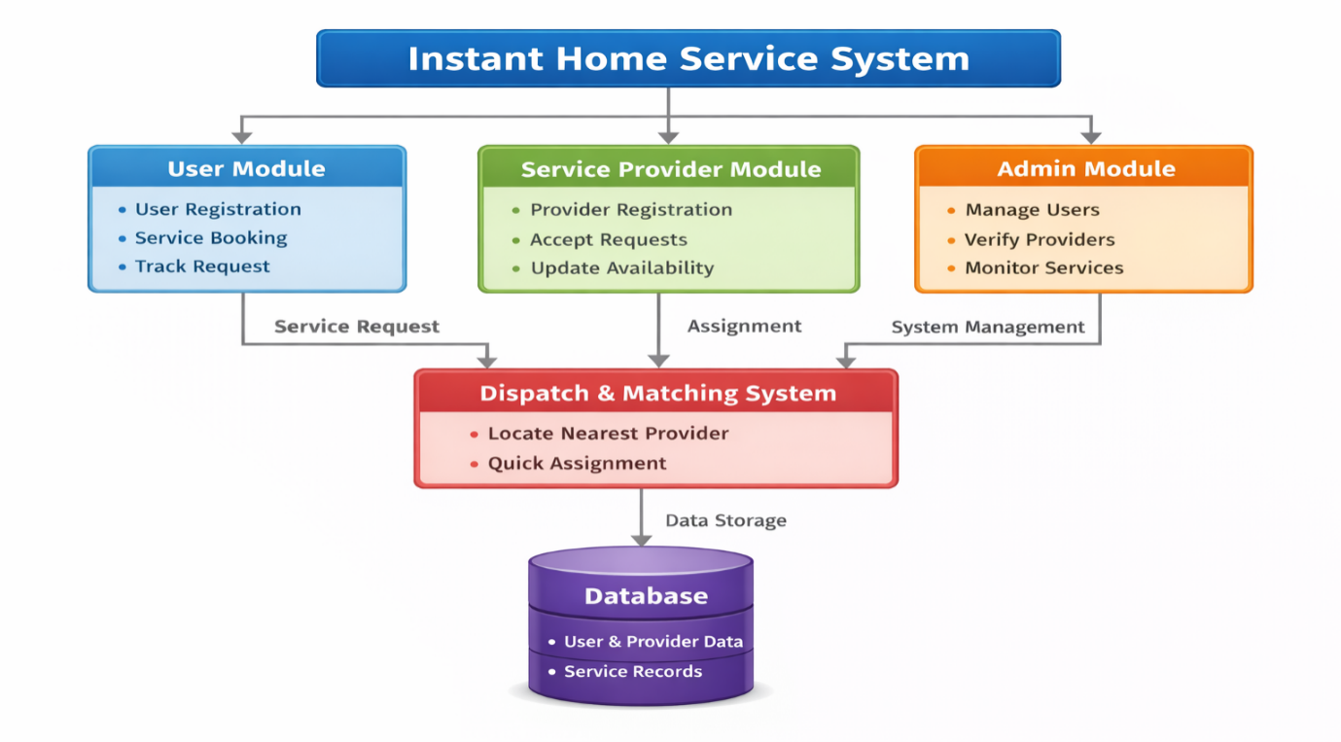
Fig.5.1Instant Home Service System Architecture
Fig 5.1 outlines the architecture of an Instant Home Service System, which is designed to connect customers with local service professionals (like plumbers, electricians, or cleaners) quickly and efficiently.
Here is a breakdown of how the system is structured, divided into three main operational layers:

5.1. The User-Facing Modules (Top Level)
These are the interfaces that different types of people use to interact with the platform:
- User Module (Blue): This is the app or website used by the customer.
  - It allows them to create an account (User Registration).
  - They can request a specific job (Service Booking).
  - They can monitor the status of their request or the provider's location (Track Request).
  - Action: When a user books a job, this module sends a Service Request down to the dispatch system

- Service Provider Module (Green): This is the interface used by the workers/professionals.
  - Workers use it to join the platform (Provider Registration).
  - They can toggle whether they are currently working or not (Update Availability).
  - They use it to take on jobs assigned to them (Accept Requests).
  - Action: This module receives the Assignment from the dispatch system.

- Admin Module (Orange): This is the control panel for the platform's owners or support staff.
  - They oversee customer accounts (Manage Users).
  - They ensure workers are qualified and safe to dispatch (Verify Providers).
  - They watch over ongoing jobs to ensure quality and resolve disputes (Monitor Services).
  - Action: This provides overall System Management rules to the dispatch core.

5.2 The Core Engine (Middle Level)
- Dispatch & Matching System (Red): This is the "brain" of the platform. Instead of a human manually calling a plumber, this automated system takes the Service Request from the user and instantly scans for available workers.
  - It uses geographical data to Locate Nearest Provider.
  - It then executes a Quick Assignment, pinging the nearest available worker's phone so they can accept the job.

5.3 The Foundation (Bottom Level)
- Database (Purple): Every action taken in the modules above is permanently recorded here via Data Storage.
  - It holds all the login details, profiles, and background checks (User & Provider Data).
  - It keeps a history of every job completed, including invoices and ratings (Service Records).

5. RESULTS
This chapter deals with the result demonstration
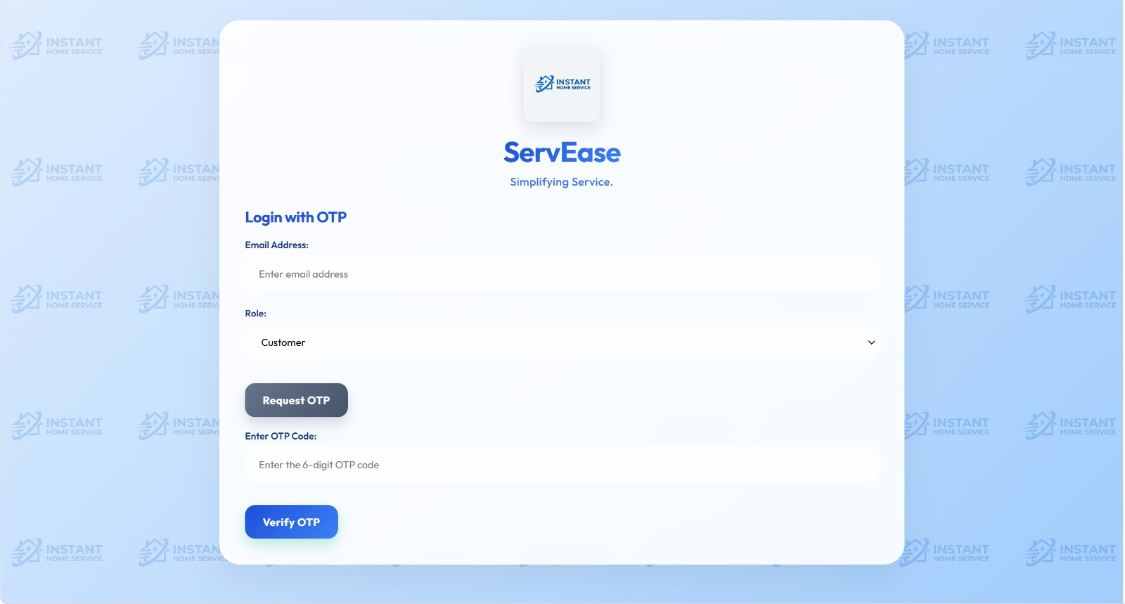
Fig:5.1 It features a secure, OTP-based authentication form including fields for email entry, role selection, and code verification

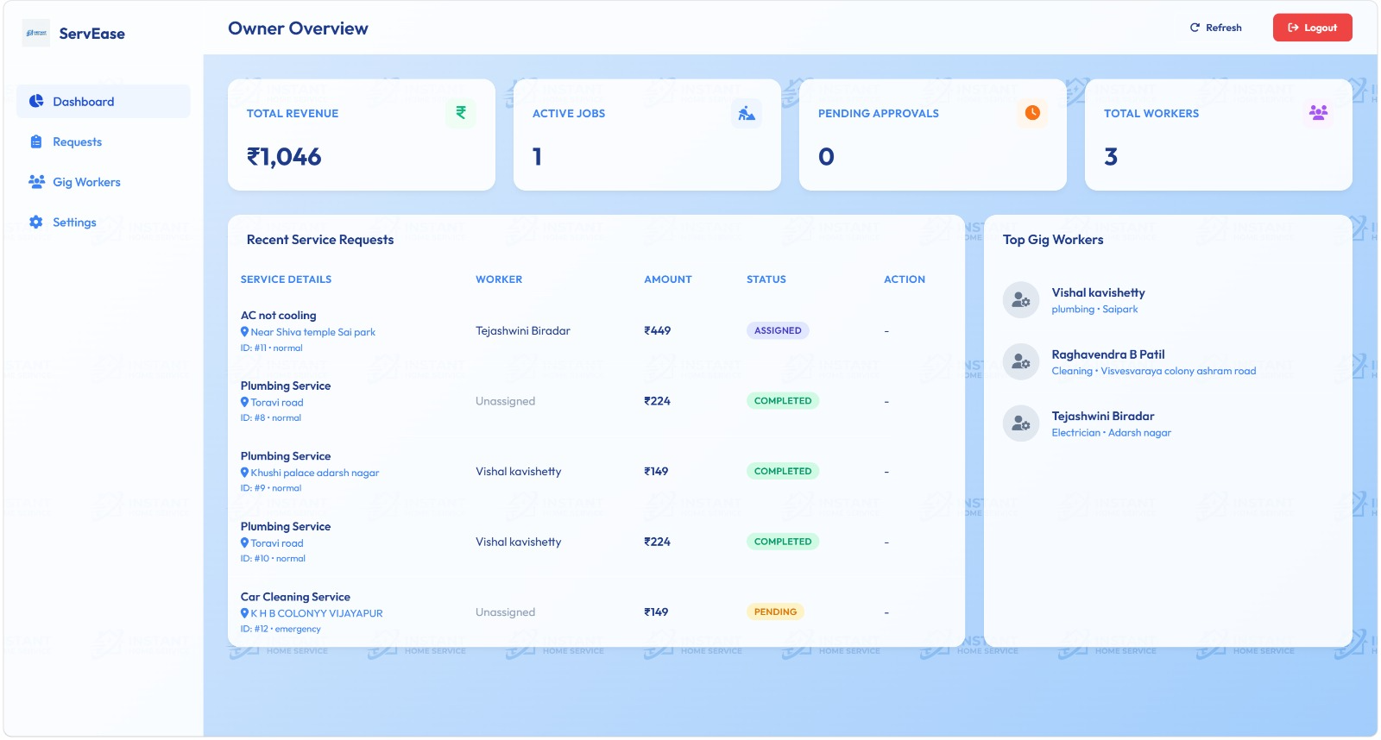
Fig :5.2 It displays an owner dashboard showing top level metrics for total revenue, active jobs, pending approvals and total workers.
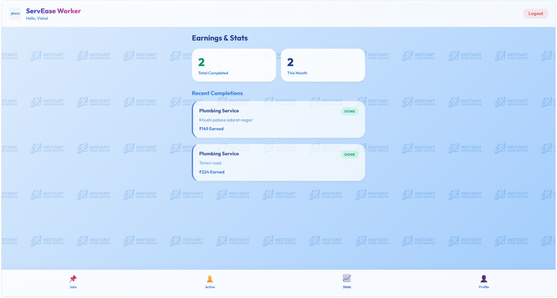
Fig 5.3: It displays dashboard of worker portal where earnings and stats are mentioned

- OUTCOMES AND APPLICATIONS
6.1 OUTCOMES:
The developed Instant Home Service System successfully provides a unified, location-aware web interface that bridges the gap between local service providers and end users for plumbing, cleaning or household services.
Robust Architectural Deployment: The project successfully established a highly responsive, secure, and scalable multi-tier web application architecture. The frontend provides a seamless user experience across multiple device viewports, while the backend efficiently manages complex asynchronous booking operations, geographical data indexing, and state management.
Highly Optimized Hyperlocal Service Discovery: By incorporating geographic location tracking and spatial query filtering, the platform accurately maps a customer’s instant request to the closest available, qualified service professional. This minimizes the matching latency from hours to a matter of seconds, ensuring rapid deployment for critical situations like plumbing emergencies or electrical hazards.
Automated Scheduling and Vendor Dispatch Management: The system successfully eliminates human administrative overhead by implementing a dynamic scheduling engine. The algorithm balances immediate "instant dispatch" allocations with future-dated, calendar-based bookings, allowing service providers to maintain structured daily workflows via their dedicated dashboards.
Transparent Accountability Mechanics: Through a centralized peer-review and rating engine, the platform captures explicit user feedback and completion media. This produces a self-regulating marketplace where top-performing technicians gain higher visibility, thereby elevating the overall quality standard of local manual labor
6.2 APPLICATIONS:
Practical Applications: The underlying framework of this instant service model is highly versatile. Beyond basic domestic handiwork, the software architecture, matching algorithms, and dispatch mechanisms can be adapted to solve operational challenges across several diverse sectors
On-Demand Domestic Repairs: Provides instant, location-aware dispatch of verified professionals for critical household needs like emergency plumbing (pipe bursts), electrical troubleshooting (short circuits), and appliance repair.
HVAC & AC Servicing: Enables hassle-free booking for preventative cooling-filter cleaning, gas during peak seasonal demands.
Deep Cleaning & Sanitization: Connects specialized cleaning crews to users for comprehensive residential scrubbing, pest control, and post-renovation waste clearance.

CONCLUSION
In this project an attempt is made to implement instant home service system, in which an innovative digital platform is provided for service bookings such as - plumbing, electrician etc
The Instant Home Service System marks a major technological advancement in the way household maintenance is handled. It overcomes the significant drawbacks of the conventional, unorganized service market by aligning the modern need for immediate help with the accessibility of qualified local experts. By utilizing smart location-based routing, live monitoring, and an automated assignment mechanism, the system guarantees quick, transparent, and safe service execution. In the end, it supports neighbourhood professionals by offering consistent work and income, while simultaneously giving homeowners an effortless, highly convenient remedy for sudden domestic issues.
While the current architecture solves the immediate problem of connecting users to professionals, the system possesses significant potential for future technological and commercial expansion:
- AI Service Recommendations: Personalized service suggestions.

- Real-Time Service Tracking: Live technician tracking.

- Instant Chat with Professionals: communication with experts.

- Real-time Blockchain-based Authentication: Secure service provider verification

8.REFERENCES
[1] Anusha M. G., & Kiran Kumar M. N. (2022). "Home Service Management System." International Journal of Advanced Research in Science, Communication, and Technology.
[2] Aravindhan, K. et al. (2020). "Web Application Based OnDemand Home Service System." IEEE International Conference on Advanced Computing. R. Nicole, “Title of paper with only first word capitalized,” J. Name Stand. Abbrev., in press.
[3] Sheetal Bandekar, Avril D’Silva, “Domestic Android Application for Home Services” International Journal of Computer Applications, ISSN No.0975 – 8887, Volume 148 – No.6, August 2016.
[4] K. C. Cababasay, M. J. C. Notarte, and G. P. Tan, "HanAPP Buhay: Android Java-Based Mobile Commerce Application for Freelance Home Service Providers and Client Job Seekers," in 2022 International Conference on Smart Generation Computing, Communication and Networking (SMART GENCON), Bangalore, India, 2022, pp. 1-12.
[5] A. M. Fathollahi-Fard, A. Ahmadi, F. Goodarzian, and N. Cheikhrouhou, "A bi-objective home healthcare routing and scheduling problem considering patients’ satisfaction in a fuzzy environment," Applied Soft Computing, vol. 93, p. 106385, 2020. (Note: Applicable to the Dynamic Multi-Skill Workforce Scheduling Problem mentioned in your literature review).

